***Practical 10: Schema design using HBase***

**Steps involved how to Schema design using HBase below in the following order-**

Before the perform the practical first perform **3 steps** of the given following-

1. **sudo /home/cloudera/cloudera-manager --force –express**

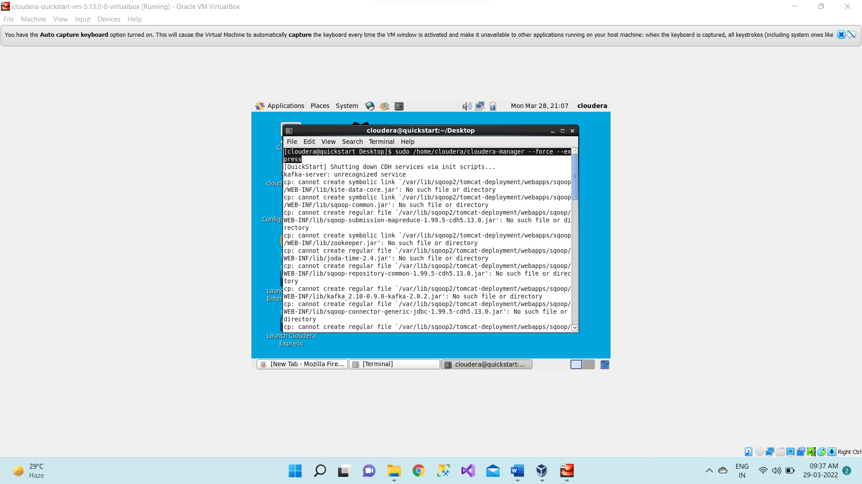

1. **Start all services**

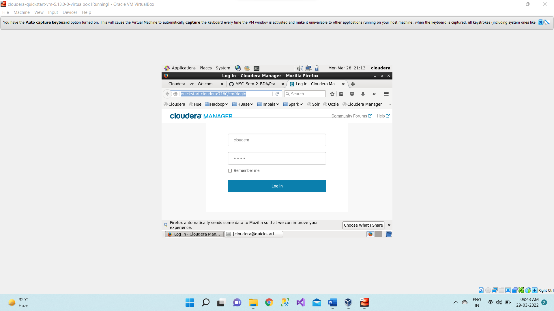

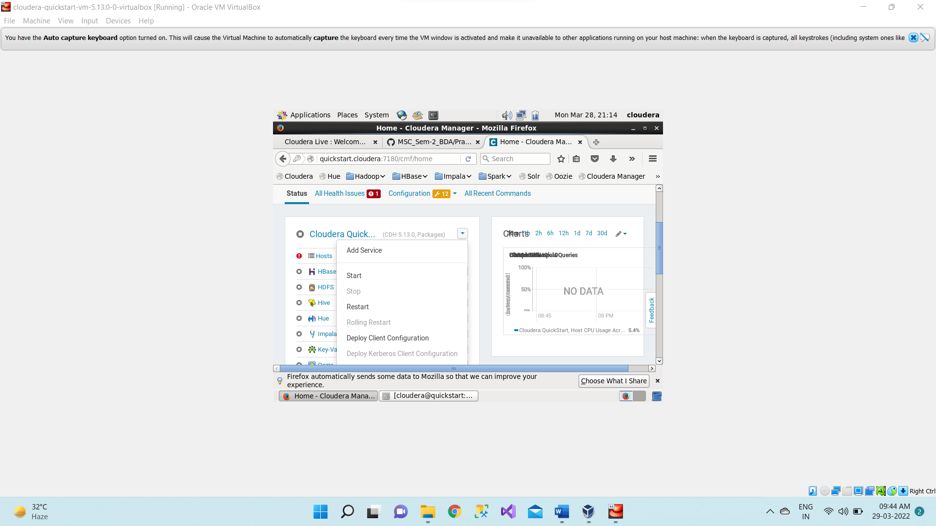

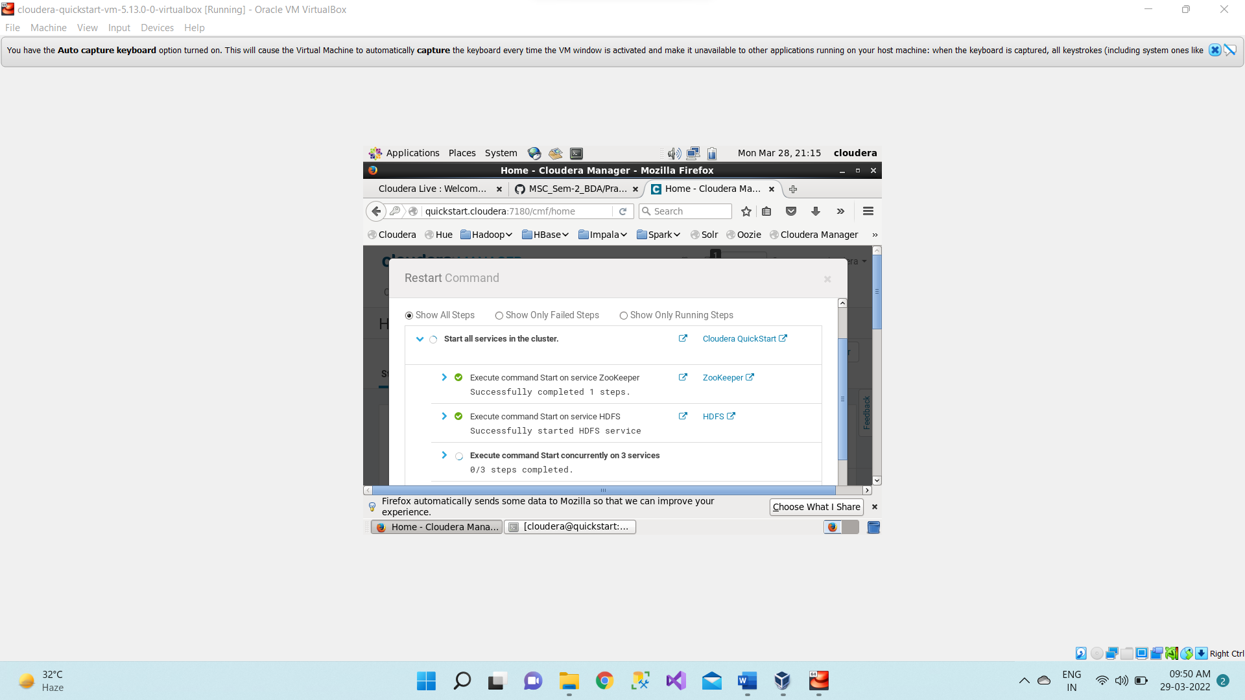

1. **sudo -u hdfs hadoop dfsadmin -safemode leave**

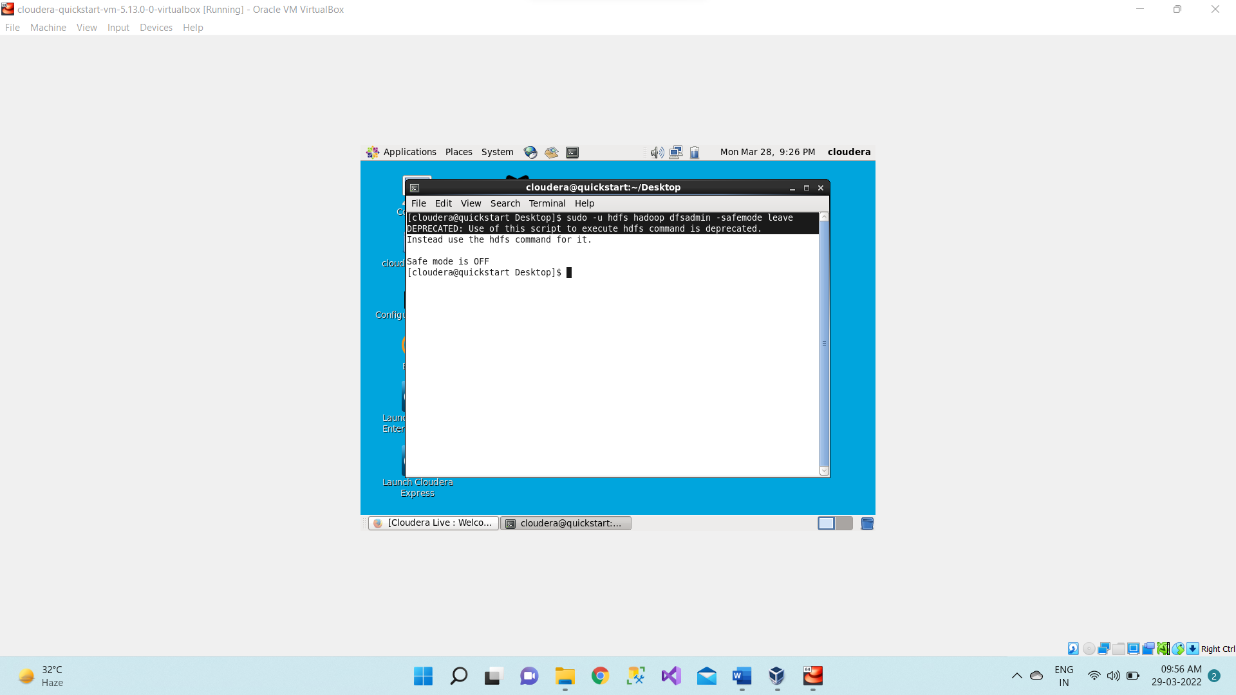

**HBase Shell**

HBase contains a shell using which you can communicate with HBase. HBase uses the Hadoop File System to store its data. It will have a master server and region servers. The data storage will be in the form of regions (tables). These regions will be split up and stored in region servers. The master server manages these region servers and all these tasks take place on HDFS. Given below are some of the commands supported by HBase Shell. We can start the HBase interactive shell using “hbase shell” command as shown below.

**$ hbase shell**

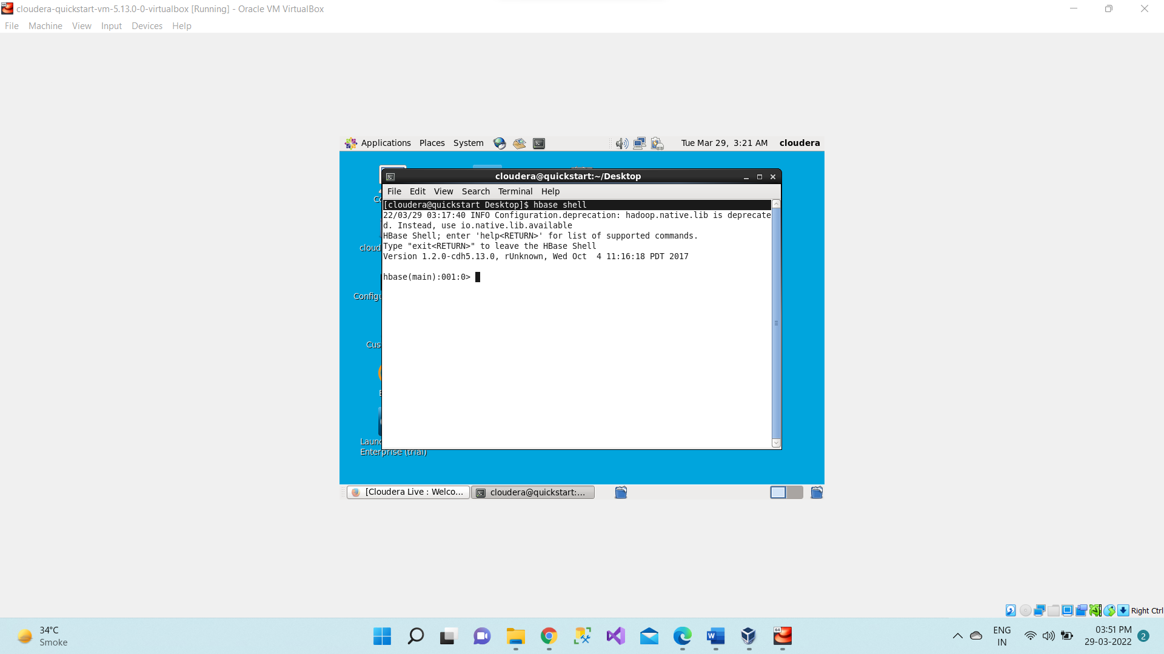

**hbase(main):001:0> list**

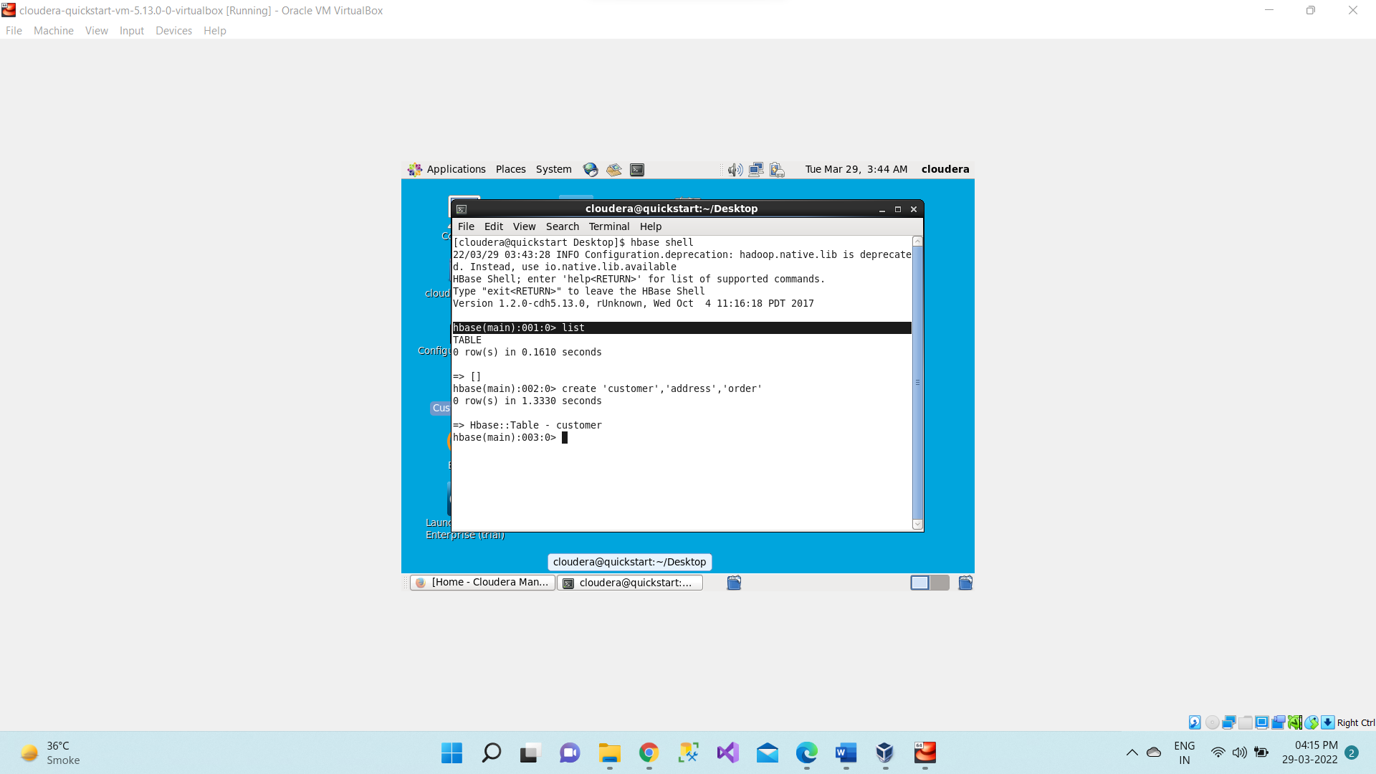

1. Creating a Table using HBase Shell

**create ‘<table name>’,’Column-Family’**

**>create ‘customer ’,’address’,’order’**

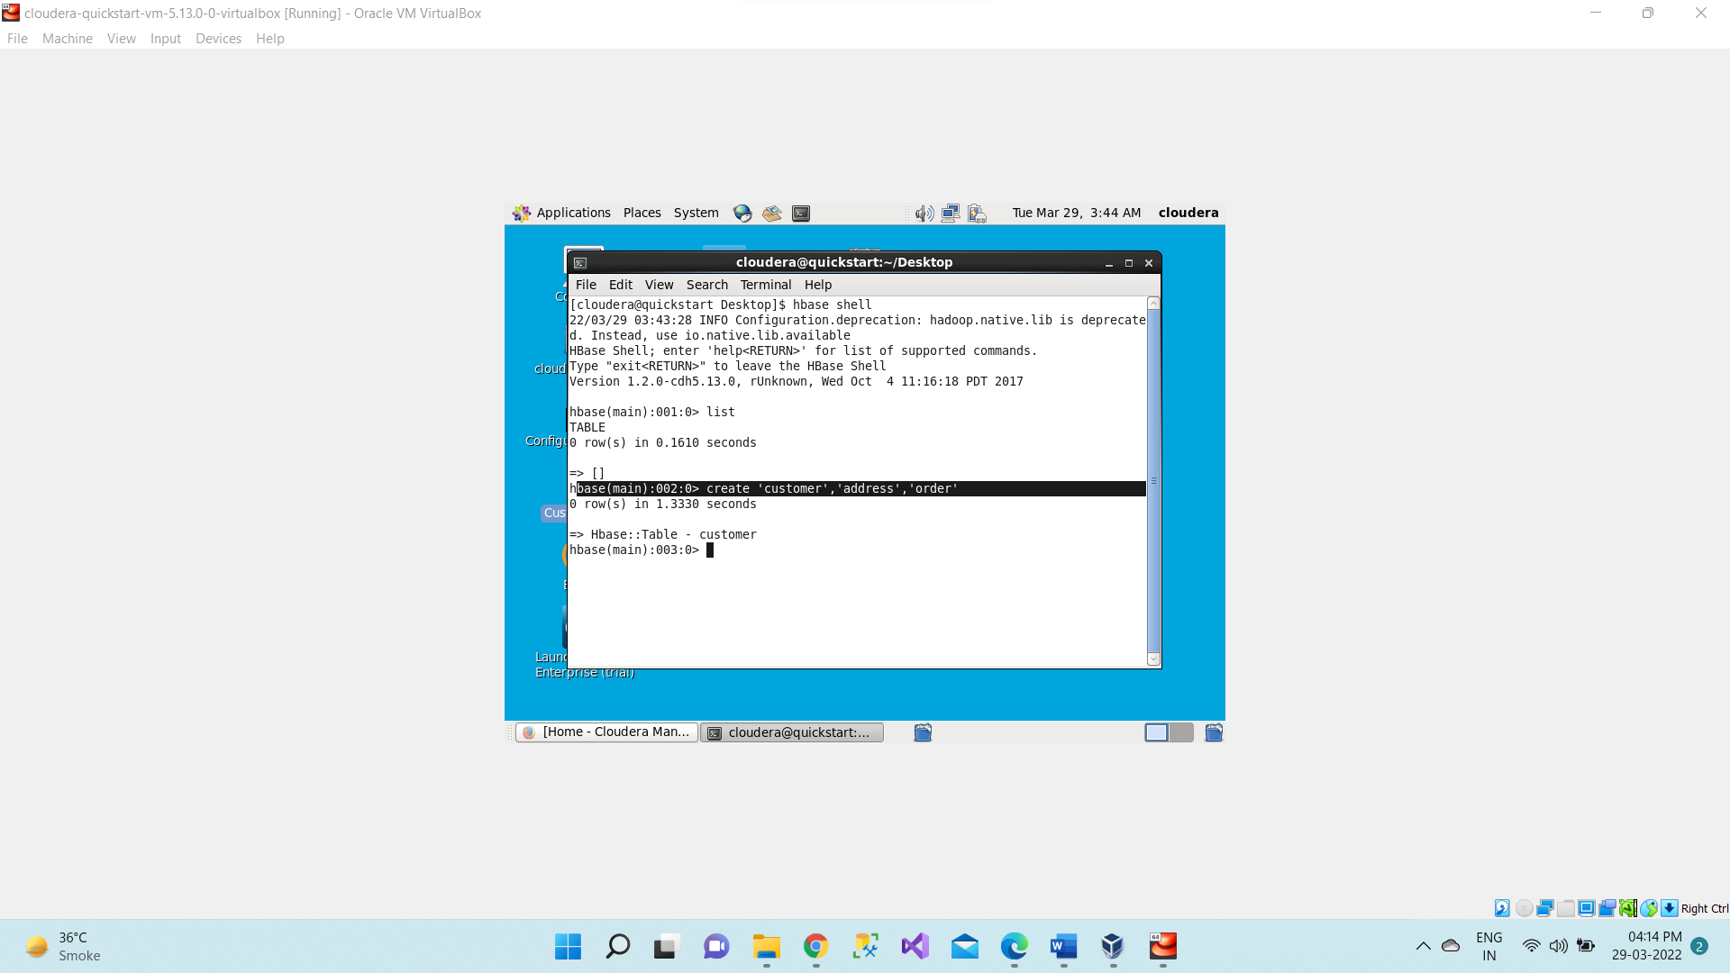

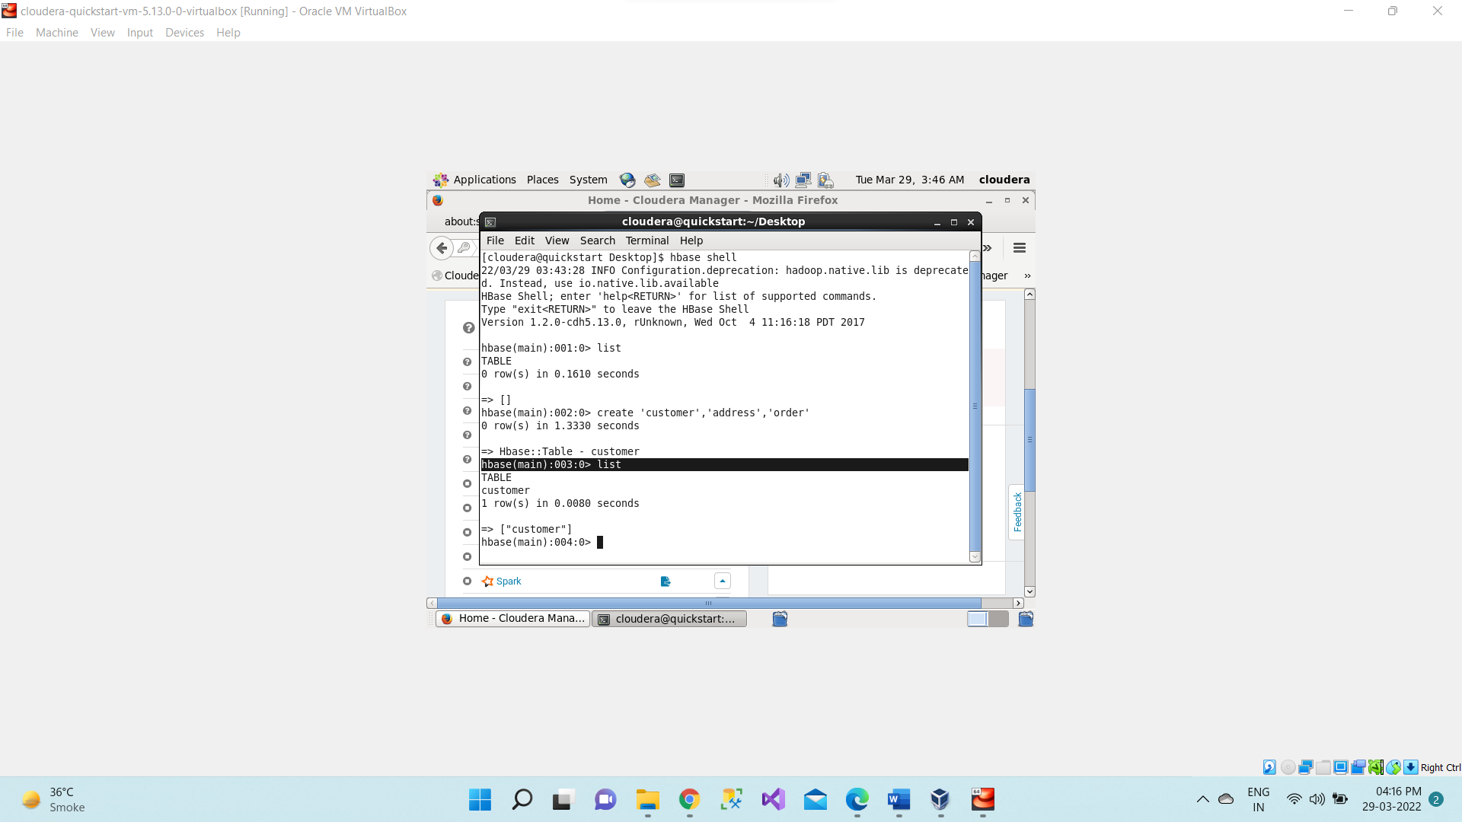

1. Put: Inserts a new record into the table with row identified by 'row..'

**put 'customer','Nick','address:city','Mumbai'**

**put 'customer','Nick','address:state','Maharashtra'**

**put 'customer','Nick','address:street','Steet1'**

**put 'customer','Nick','order:number','ORD-15'**

**put 'customer','Nick','order:amount','50'**

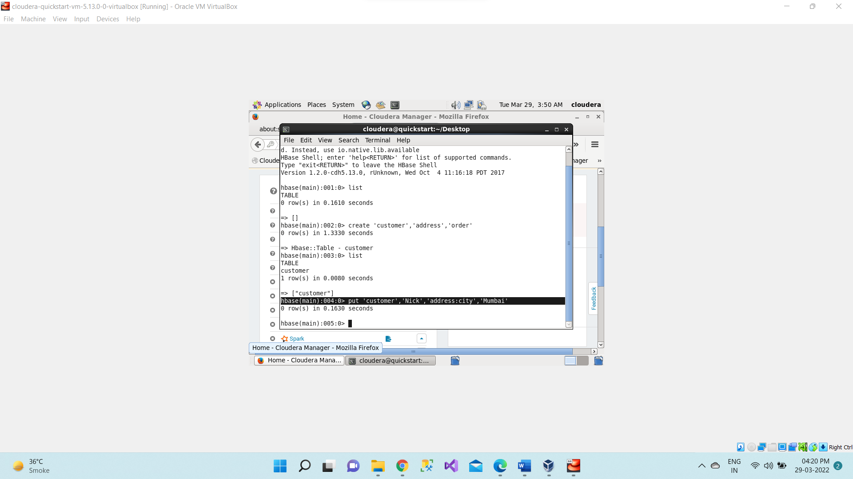

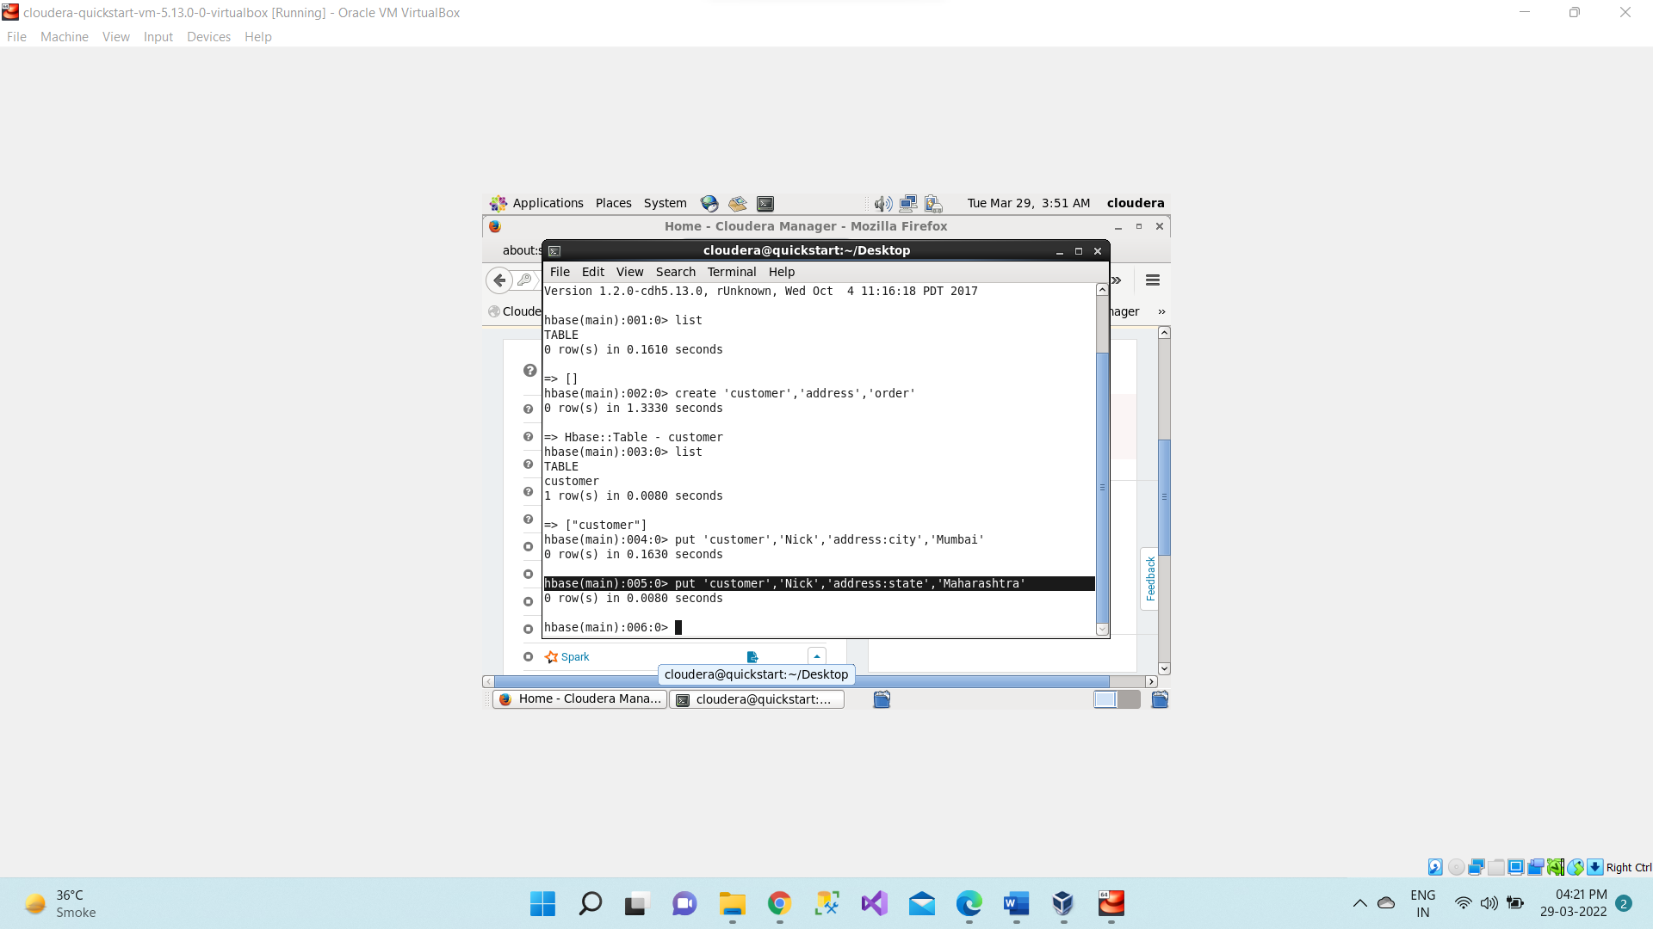

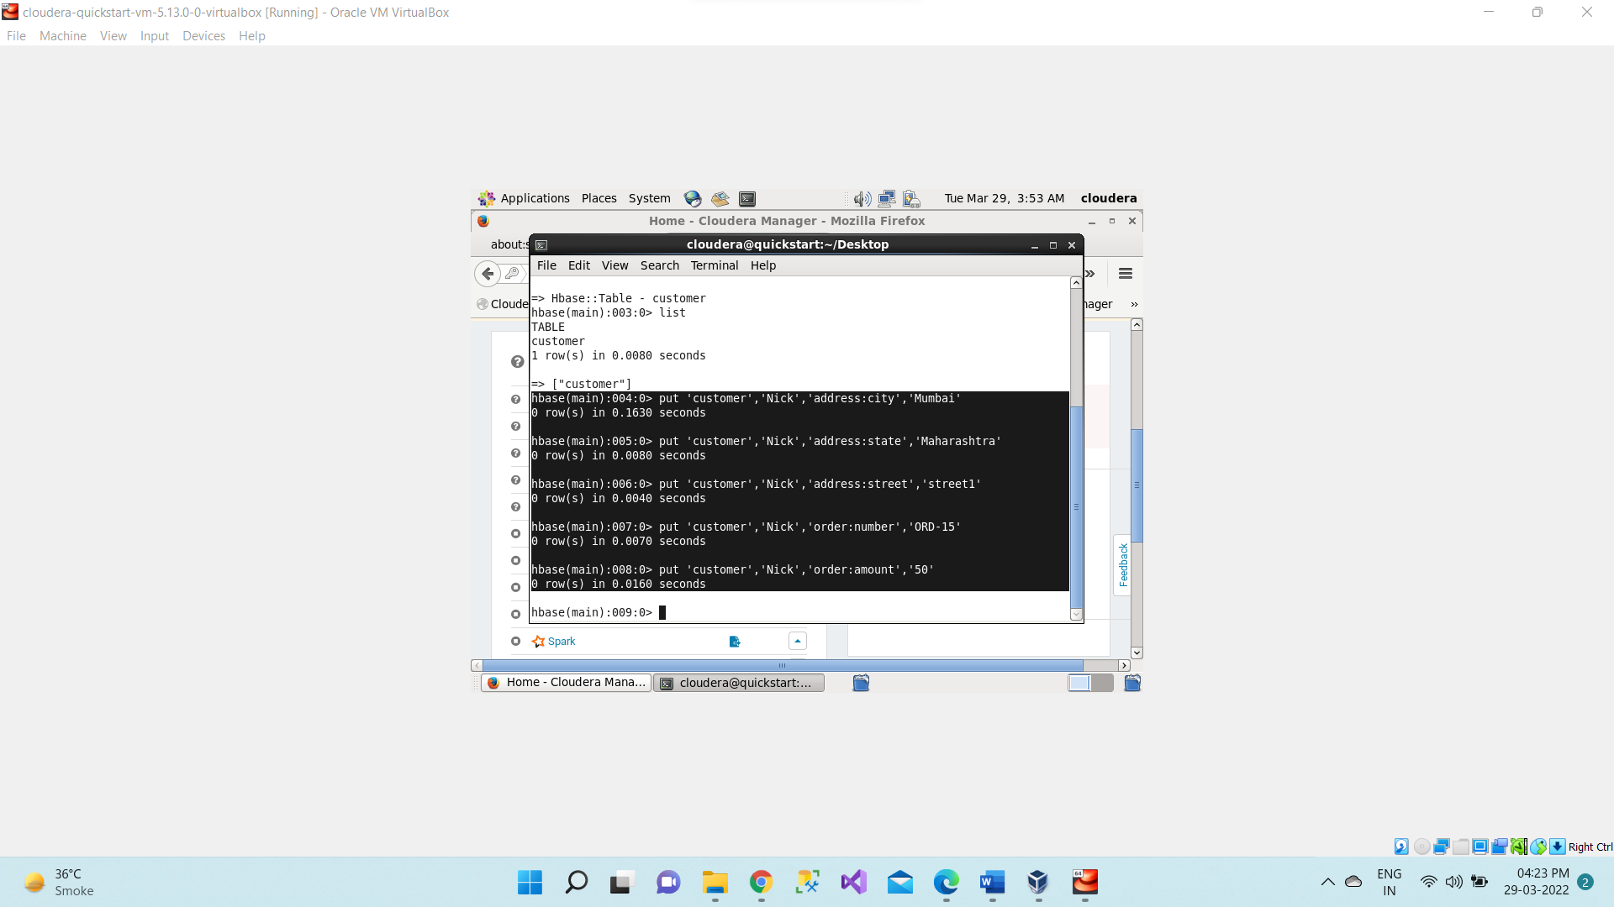

Adding one more record of customer name “Justin”.

Here name “Justin” is Row key

**put 'customer','Justin','address:city','Pune'**

**put 'customer','Justin,'address:state','Maharashtra'**

**put 'customer','Justin','order:number','ORD-16'**

**put 'customer','Justin','order:amount','60'**

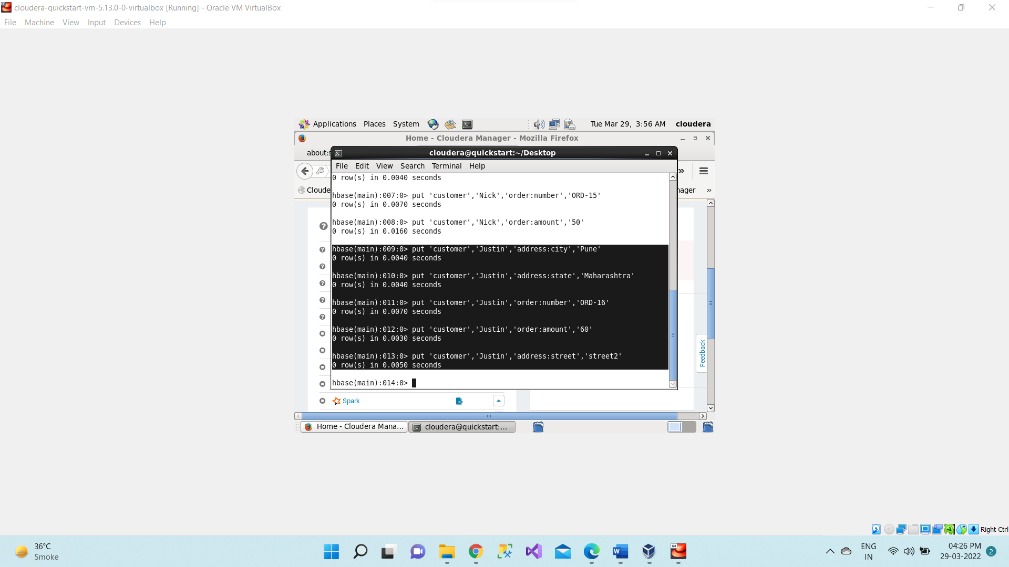

1. **Get: Returns the records matching the row identifier provided in the table**

**a) get 'customer', 'Nick'**

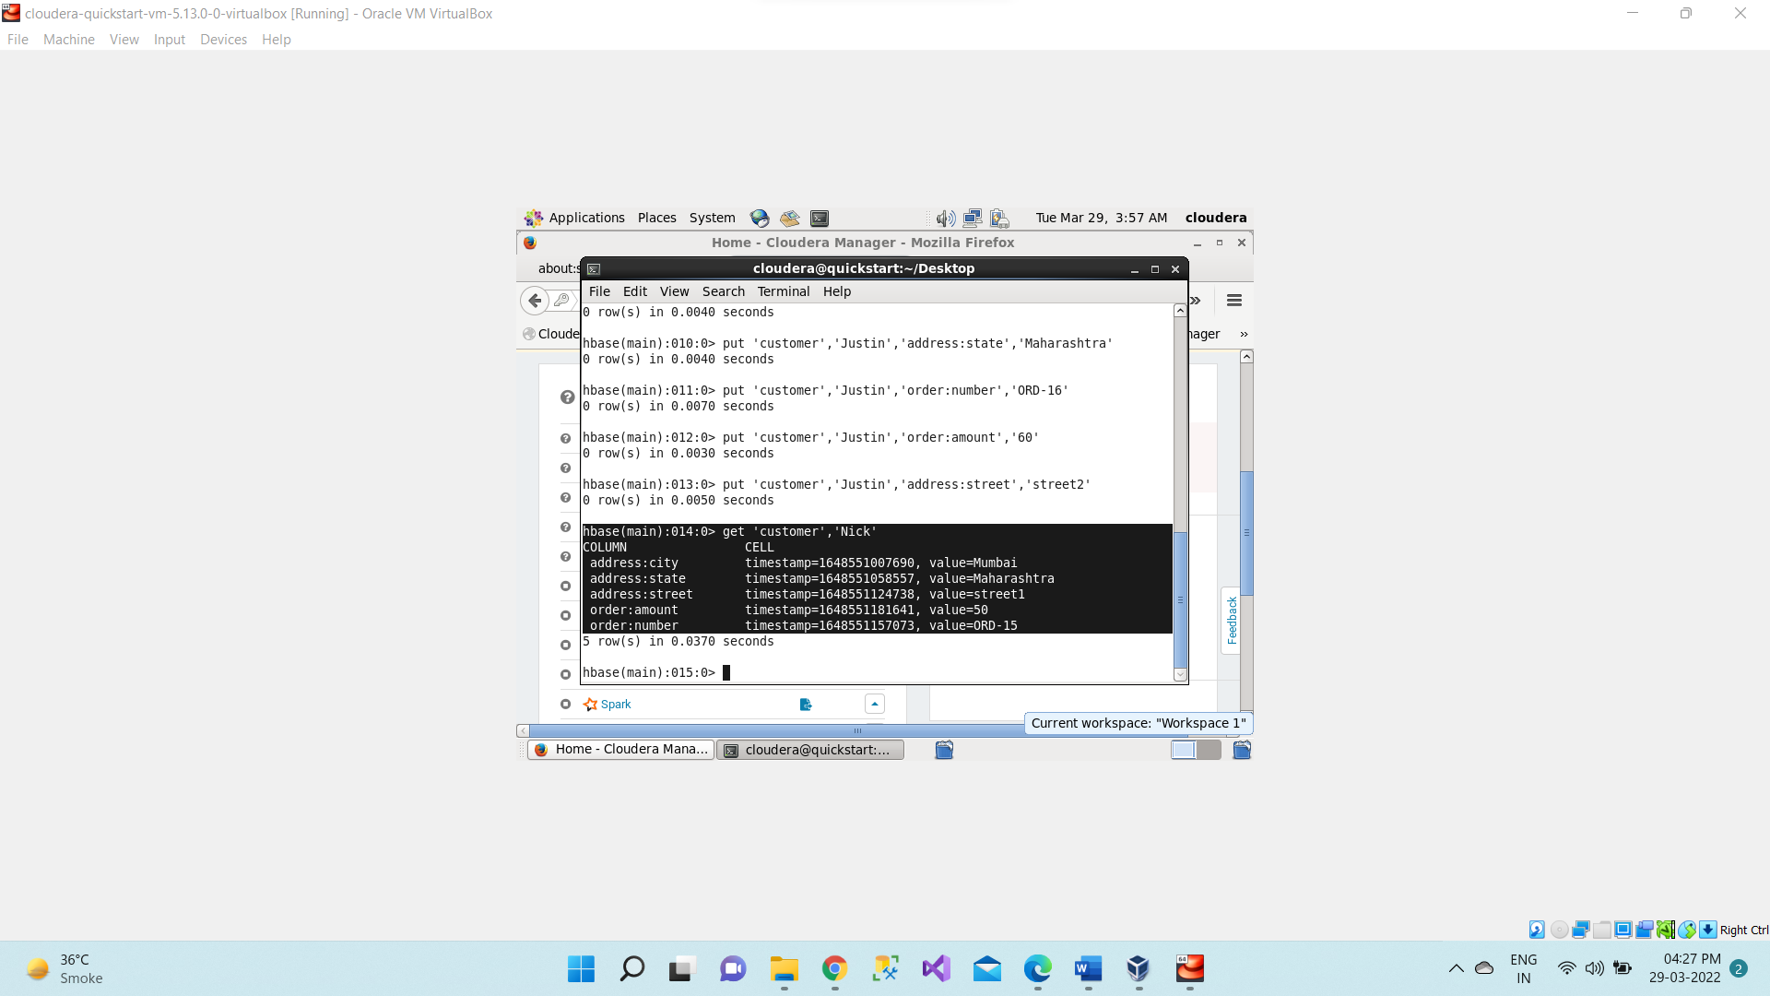

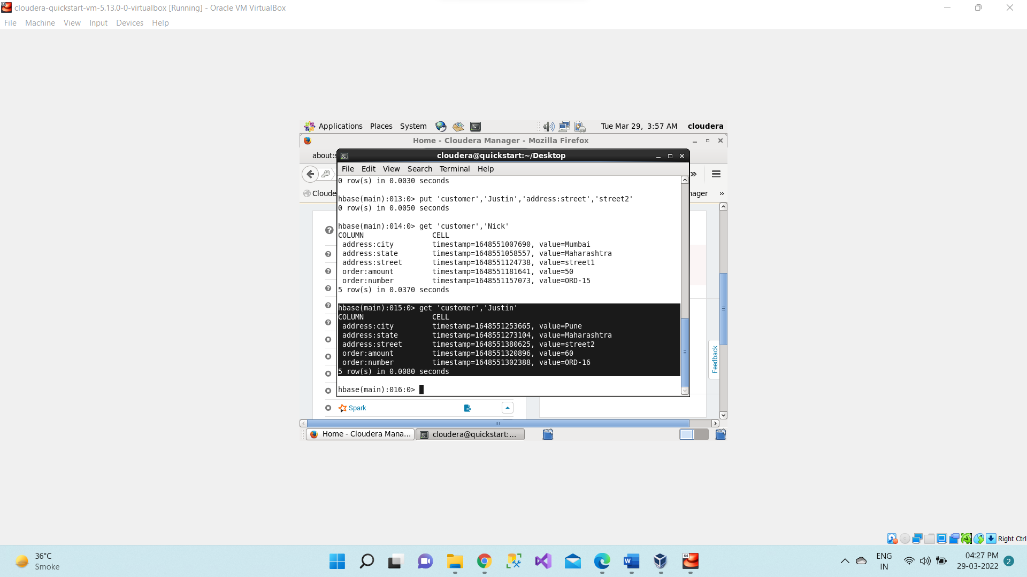

**b) Additional parameters to get only address details**

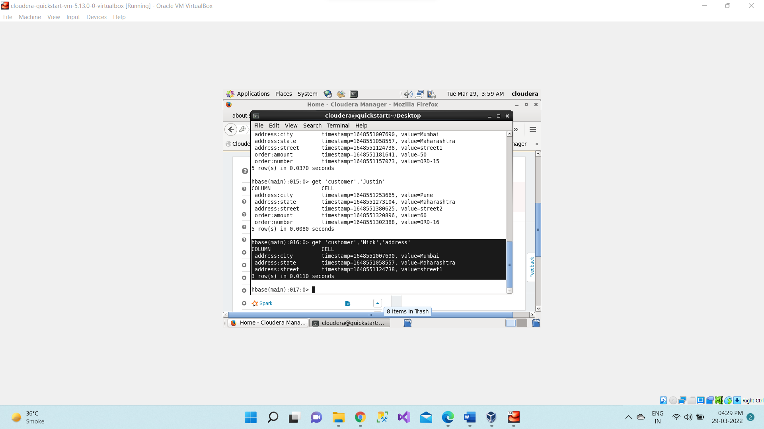

**c) Additional parameters to get only city details**

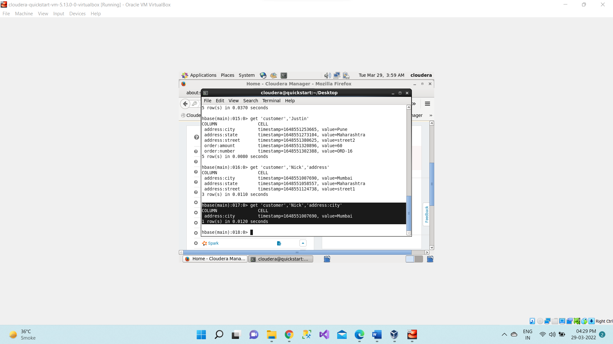

1. Scan: The scan command is used to view the data in HTable.

**scan 'customer'**

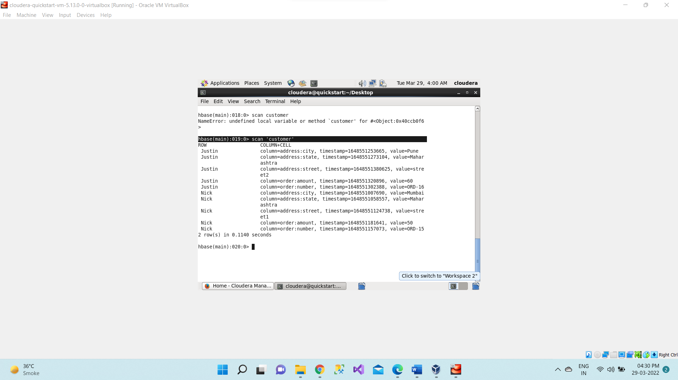

1. Delete -Using the delete command, you can delete a specific cell in a table.

**delete 'customer', 'Nick' ,'address:street'**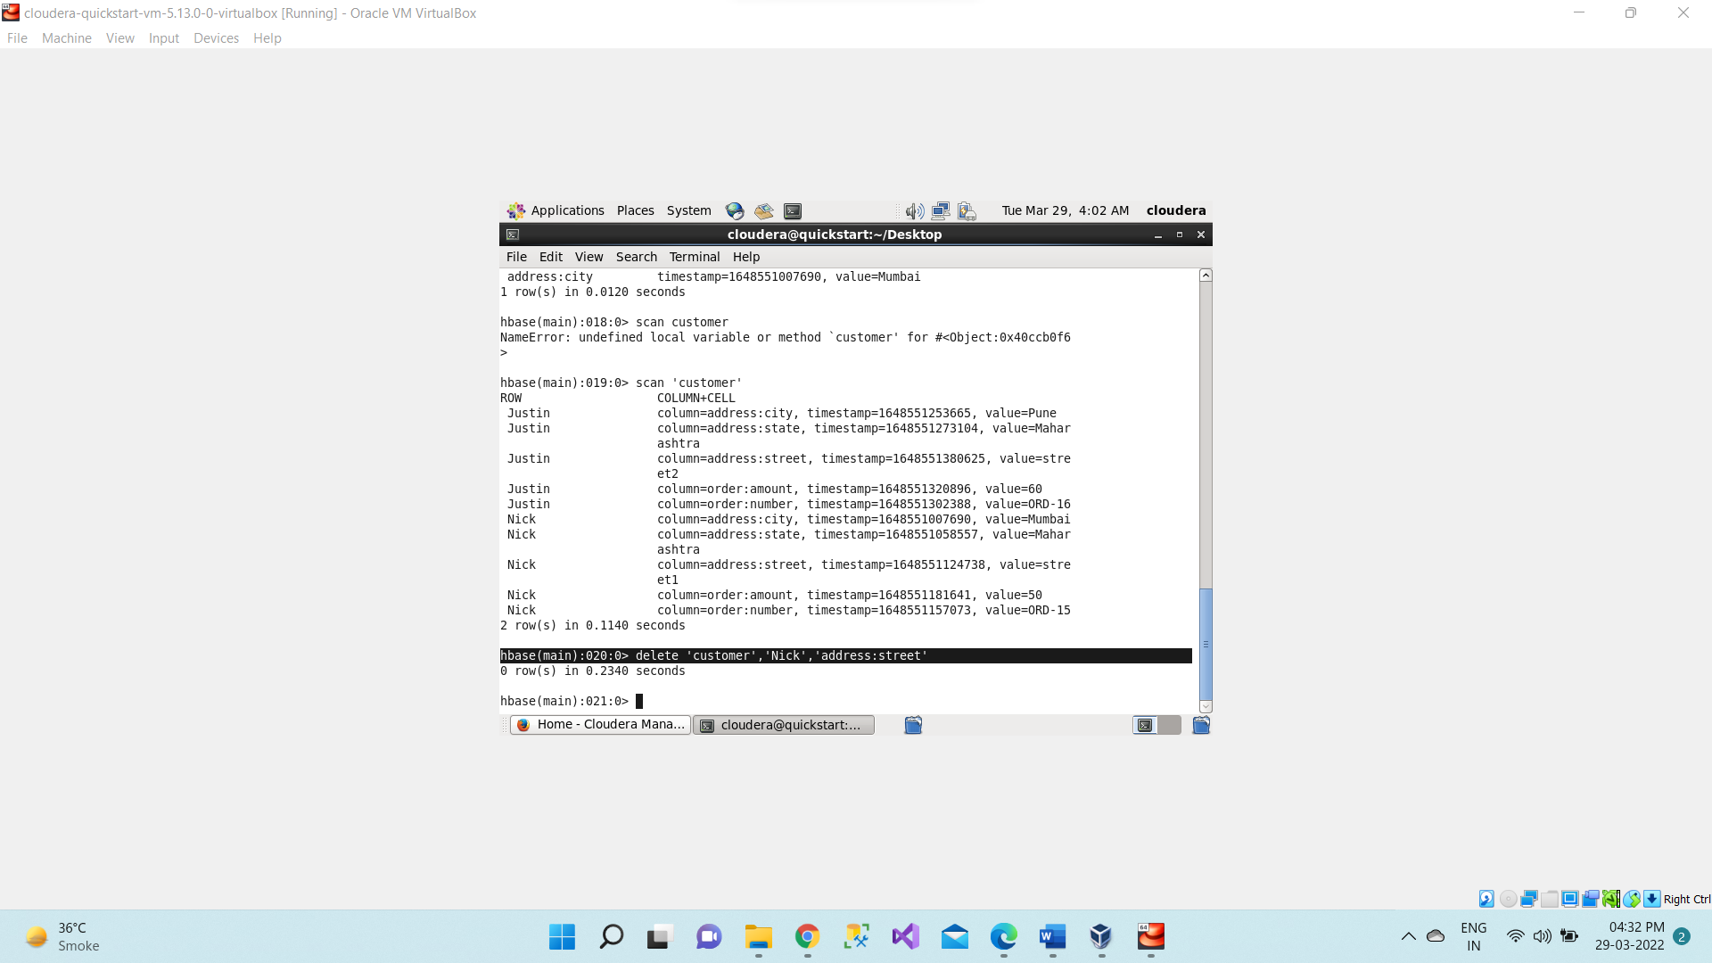

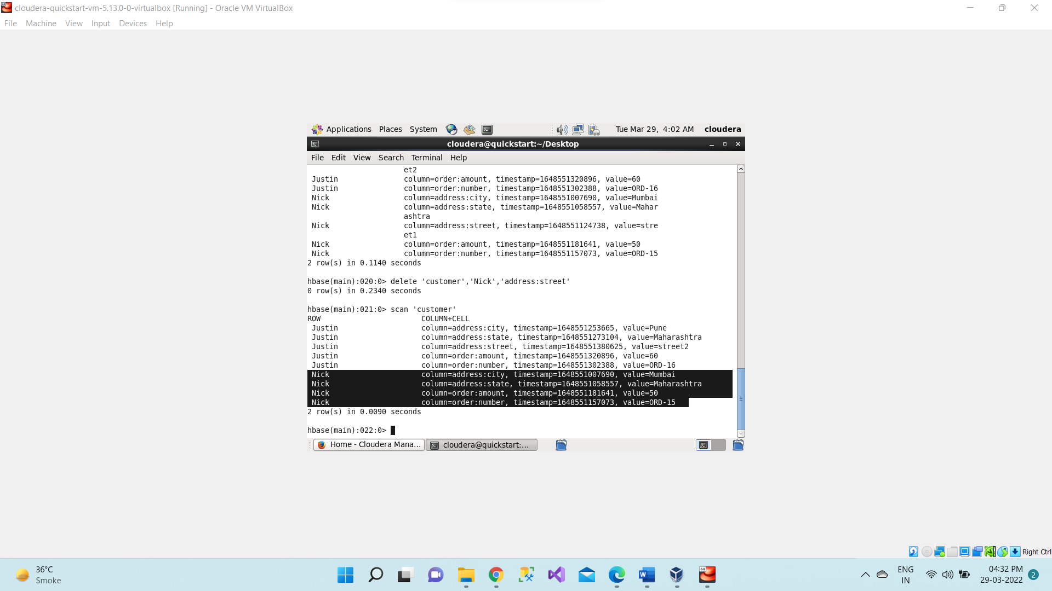

1. Alter - This command alters the column family schema. To understand what exactly it does, we have explained it here with an example.

We can delete specific column family by using alter commands

**alter 'customer', 'delete' => 'address'**

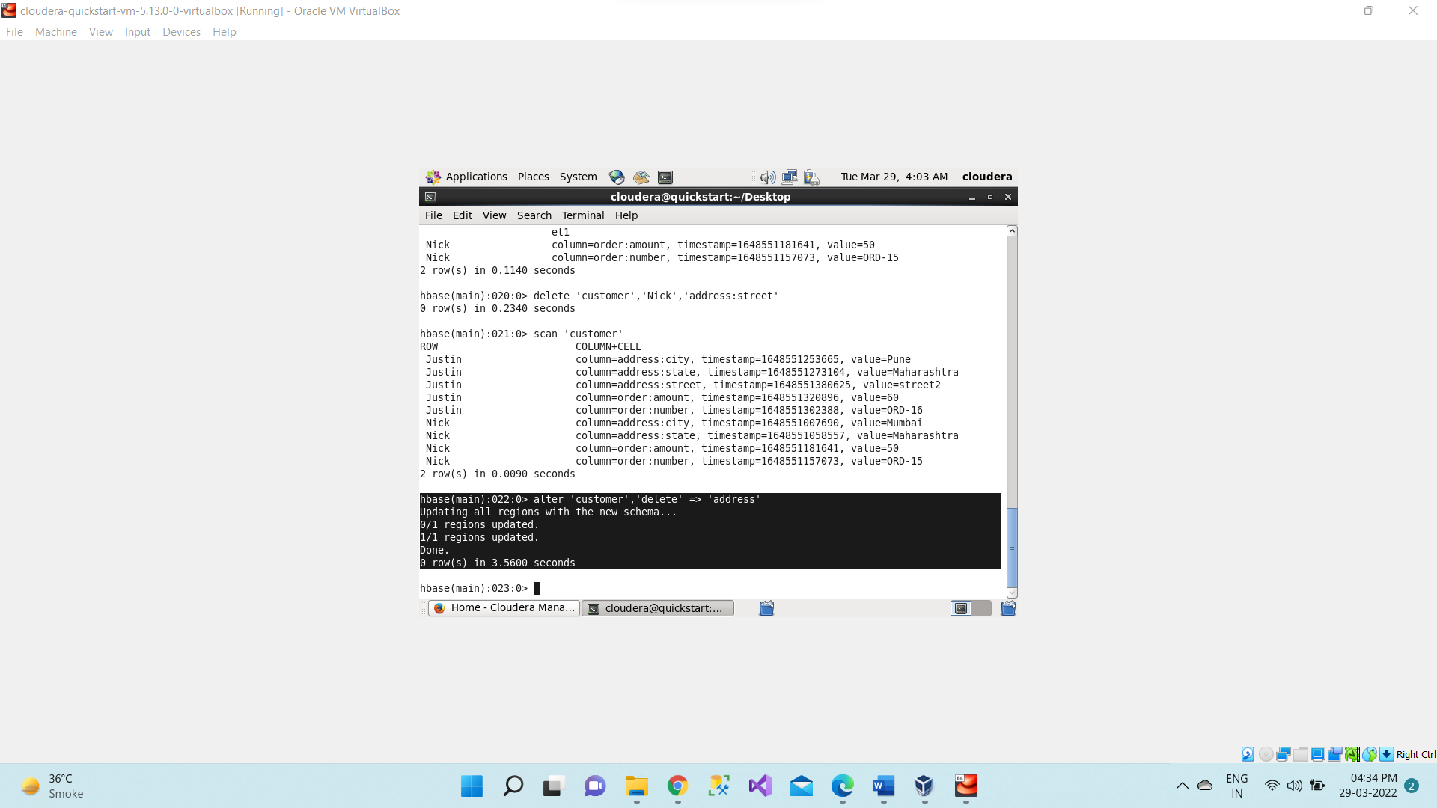

1. Describe - This command describes the named table

**desc 'customer'**

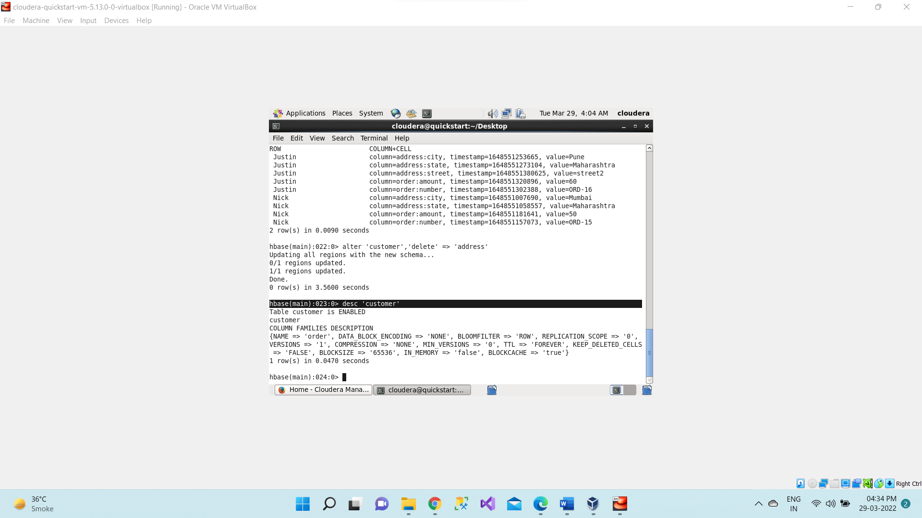

1. Versions

**create 'customer1', {NAME => 'address', VERSIONS => 3}**

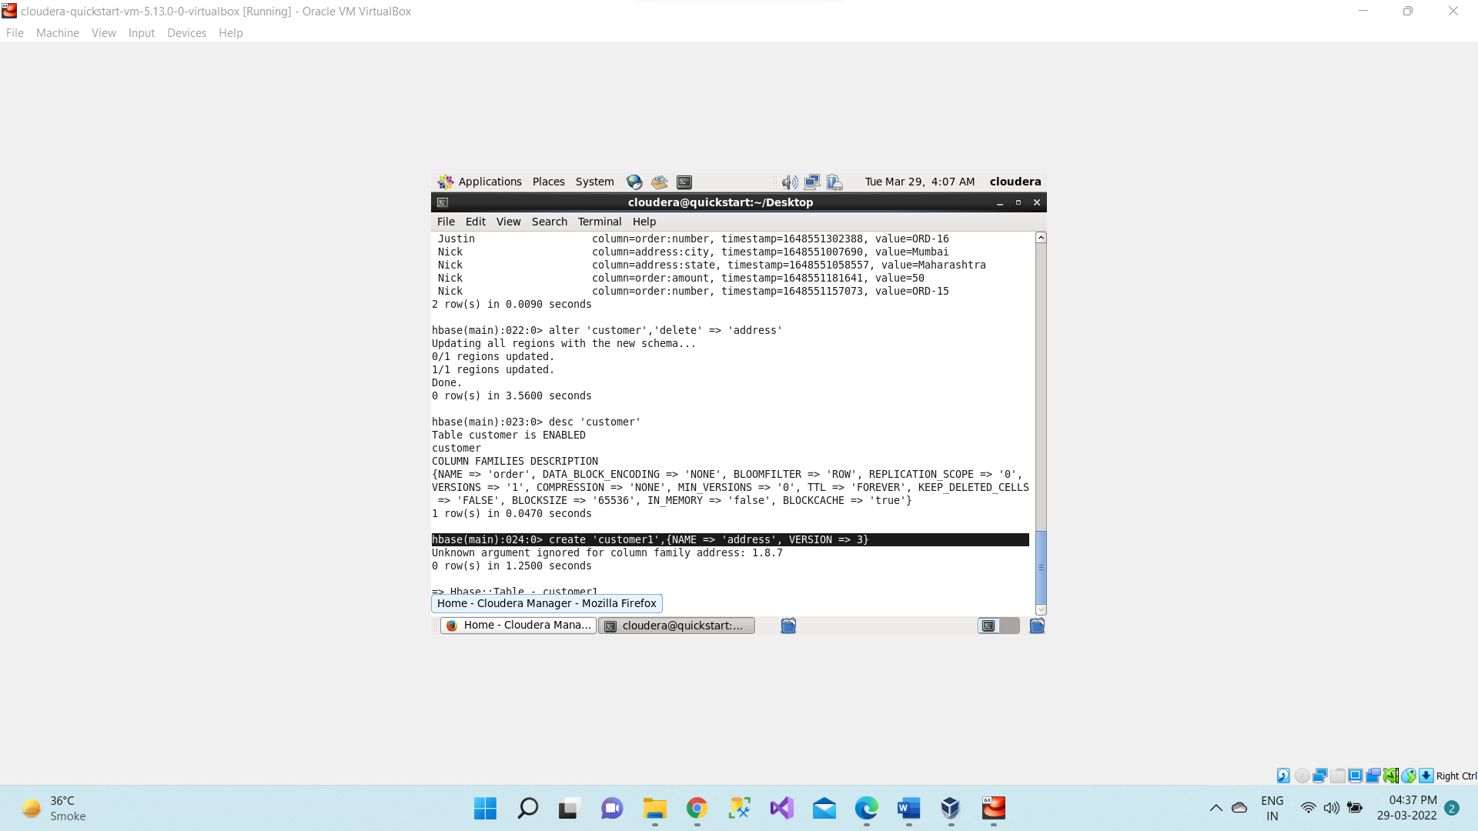

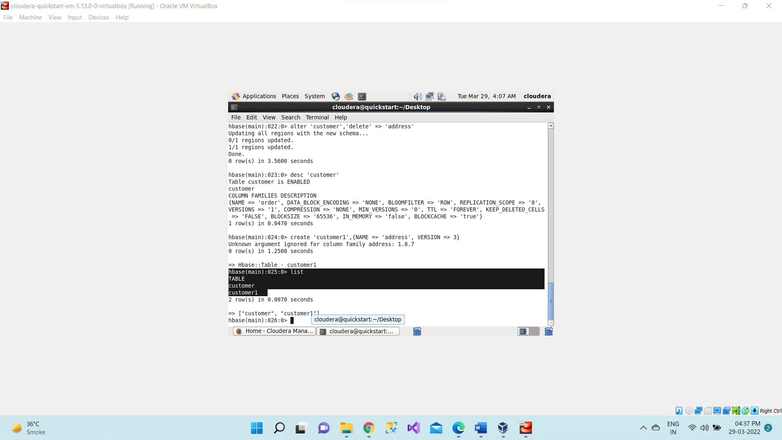

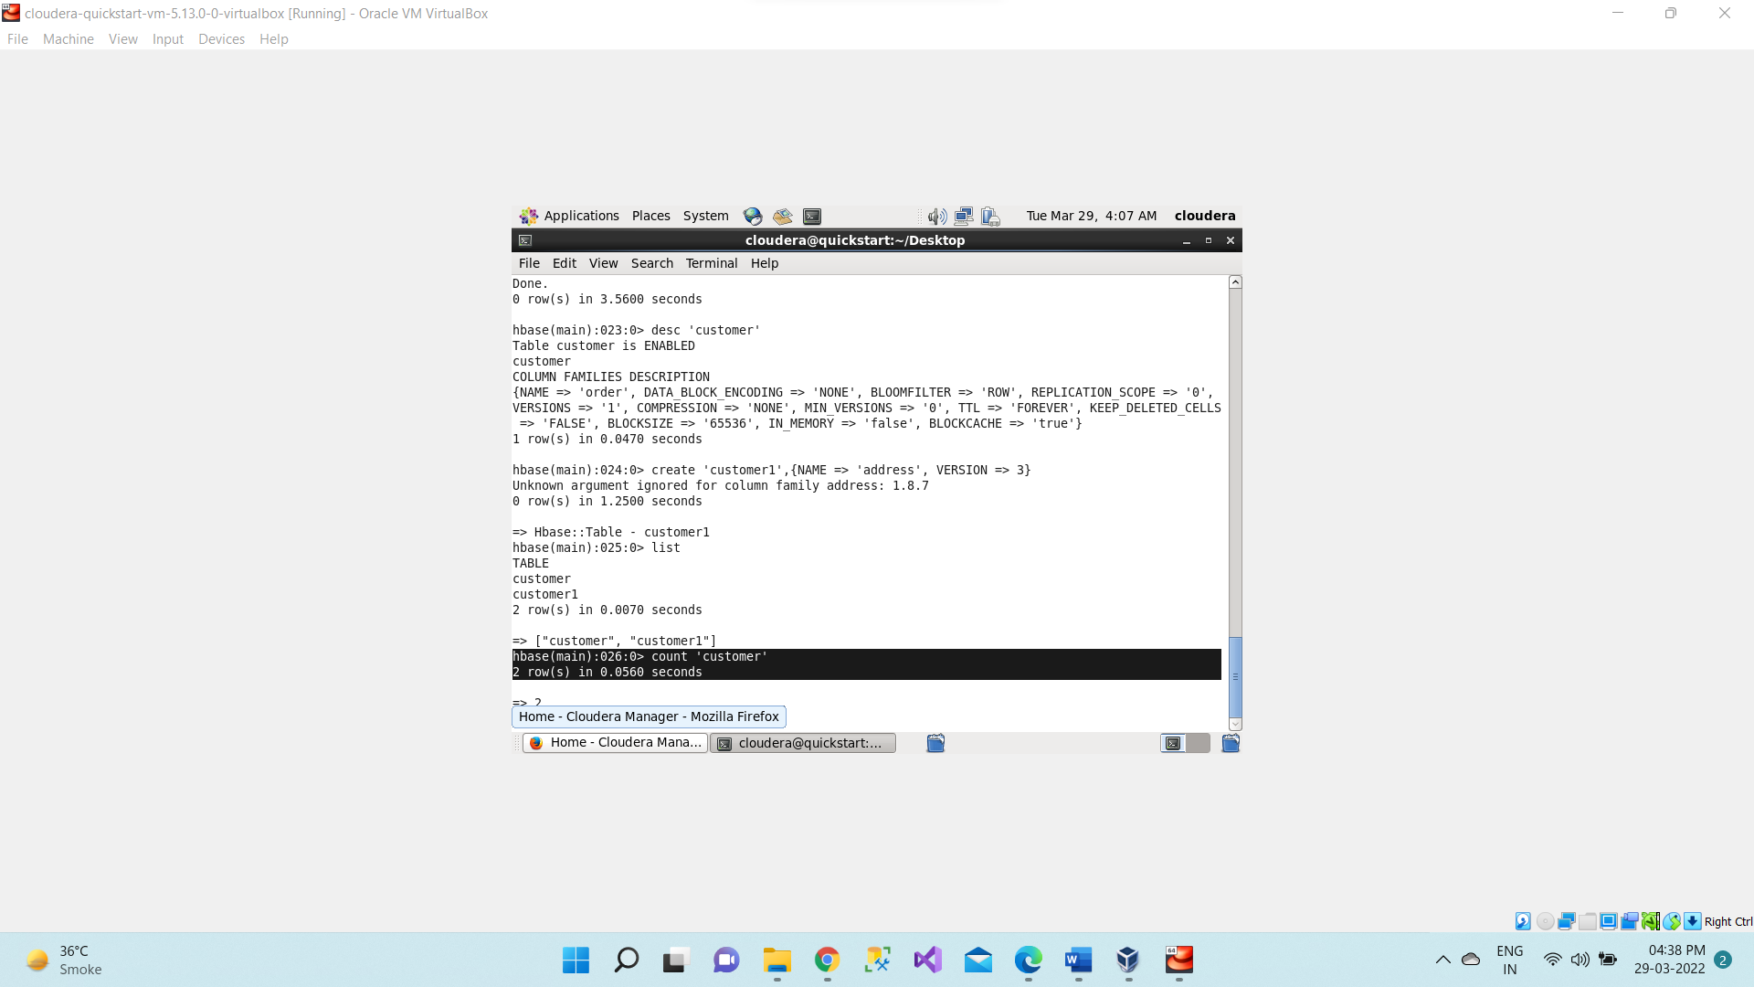

1. Alter -Update the version number for already existing columns family

**alter 'customer' , NAME => 'address', VERSIONS =>5**

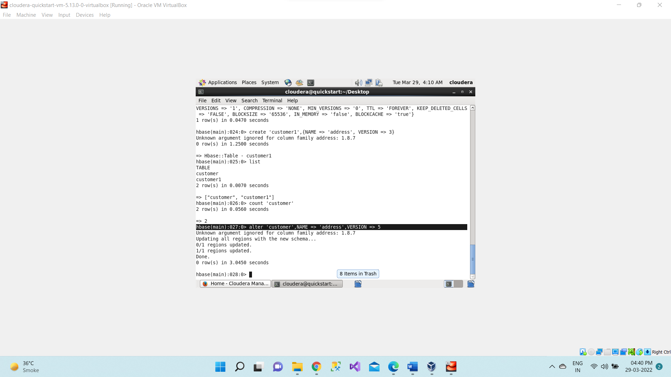

**>desc ‘customer’**

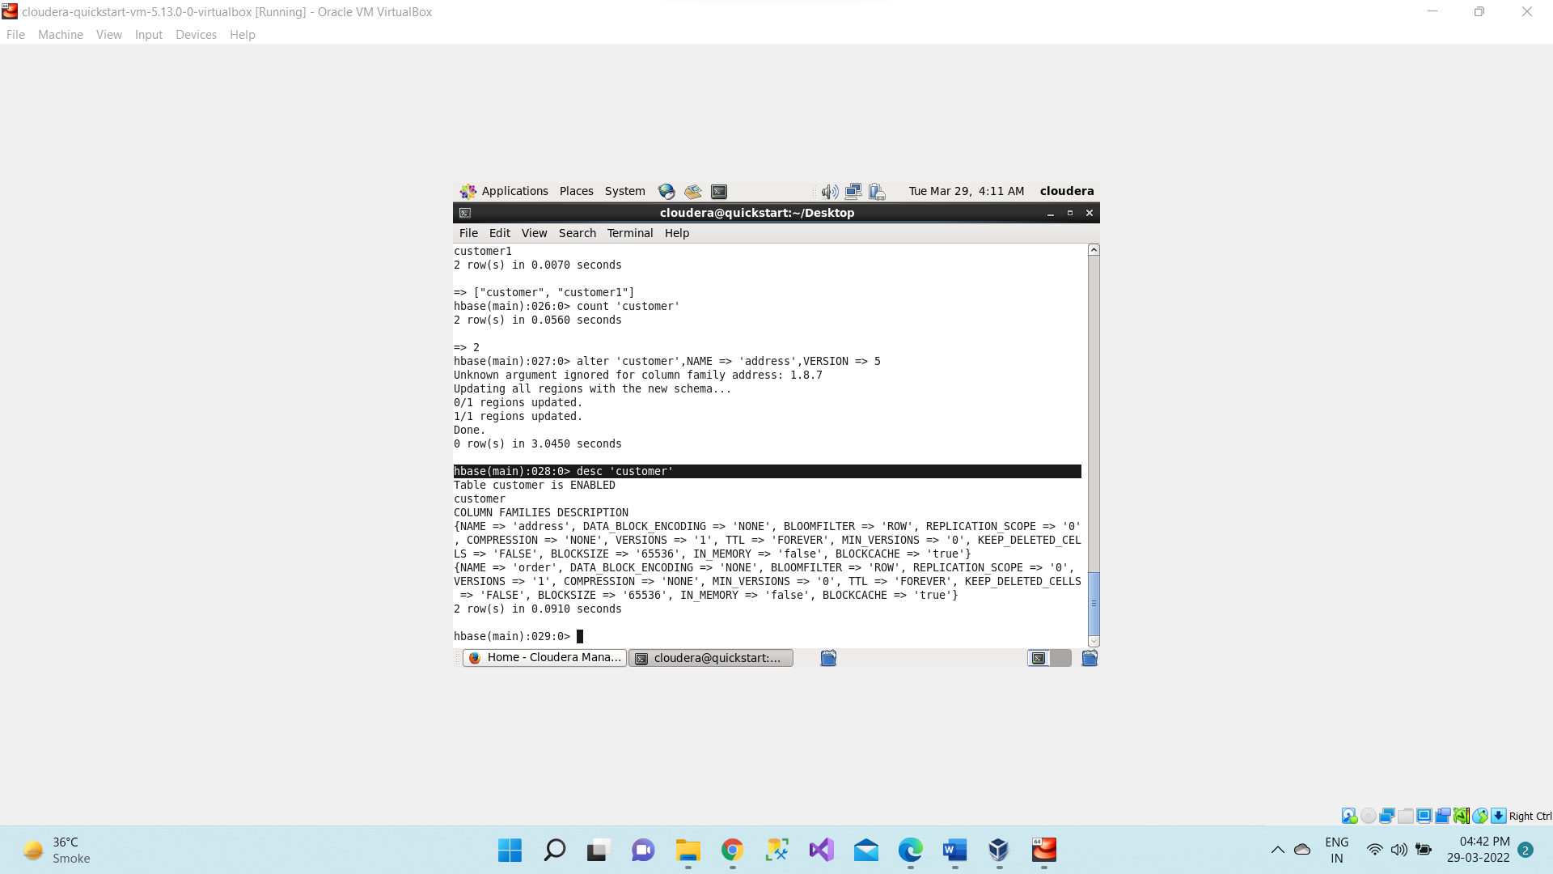

**>scan ‘customer’**

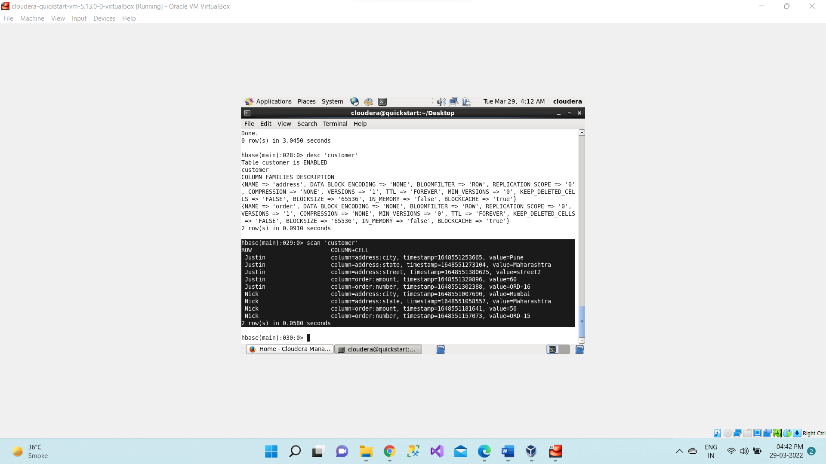

**put 'customer', 'Nick' , 'address:city', 'Pune'**

**put 'customer', 'Nick' , 'address:city', 'Bangalore'**

**put 'customer', 'Nick' , 'address:city', 'New Delhi'**

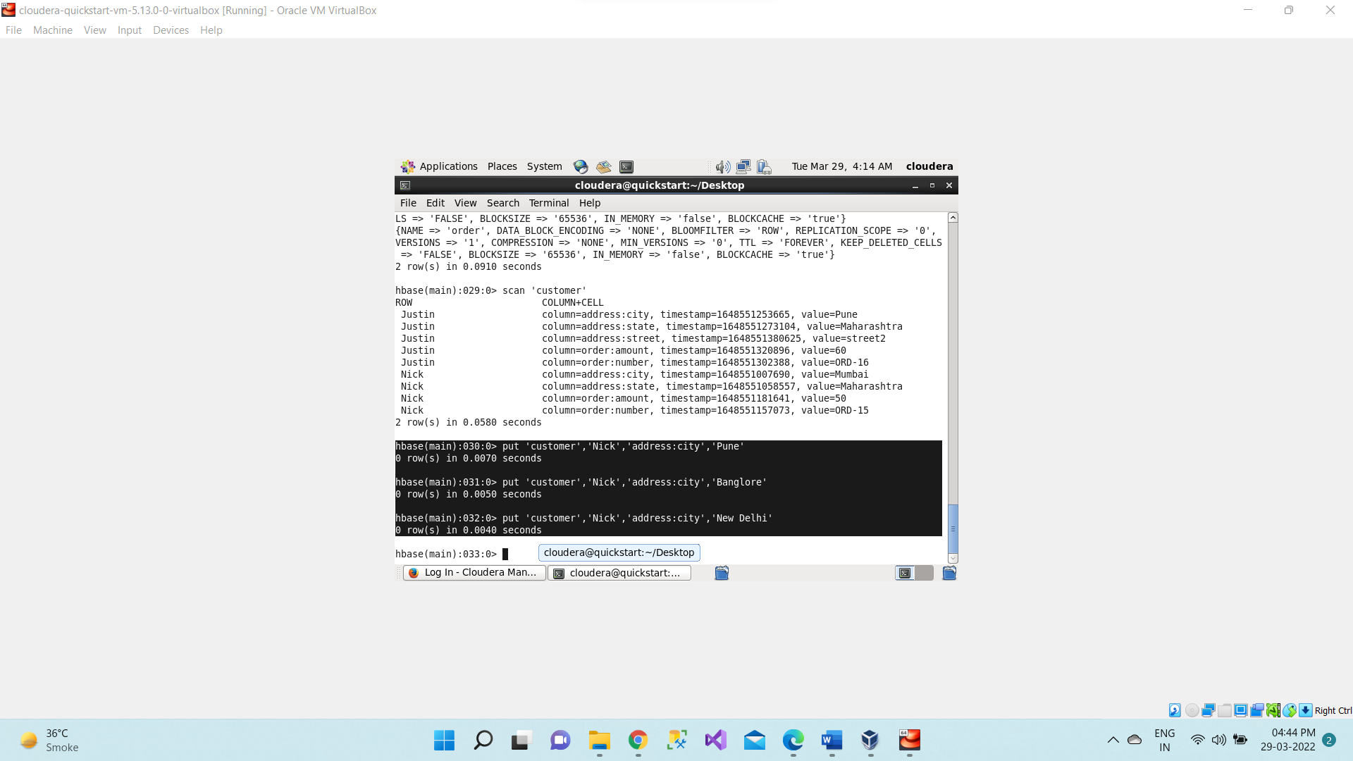

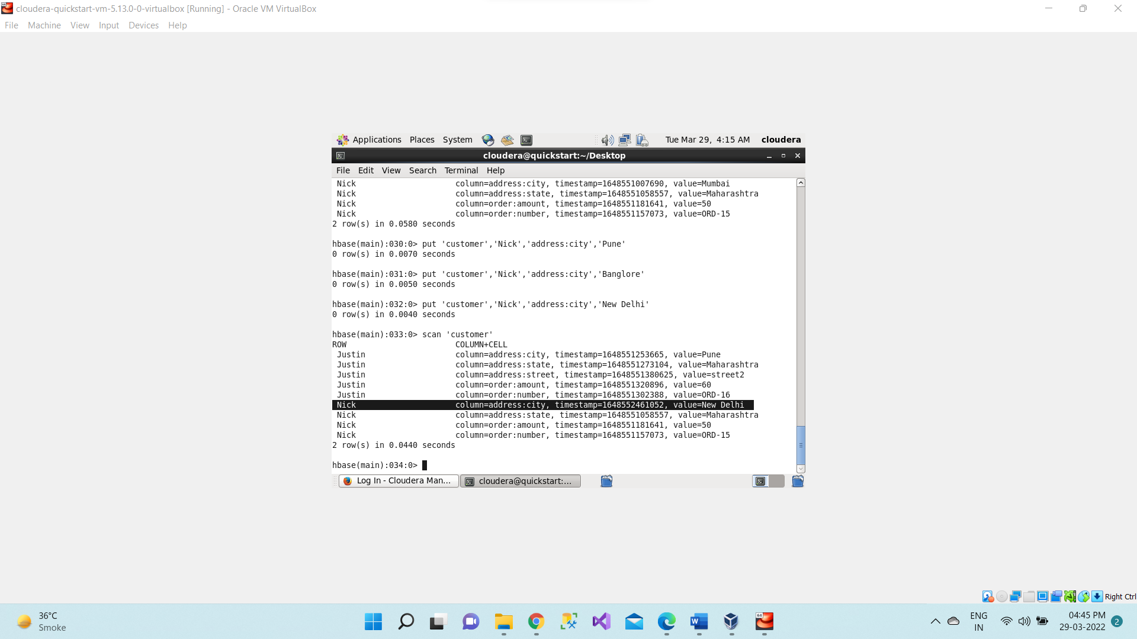

**>scan 'customer', {COLUMN=> 'address:city', VERSIONS => 2 }**

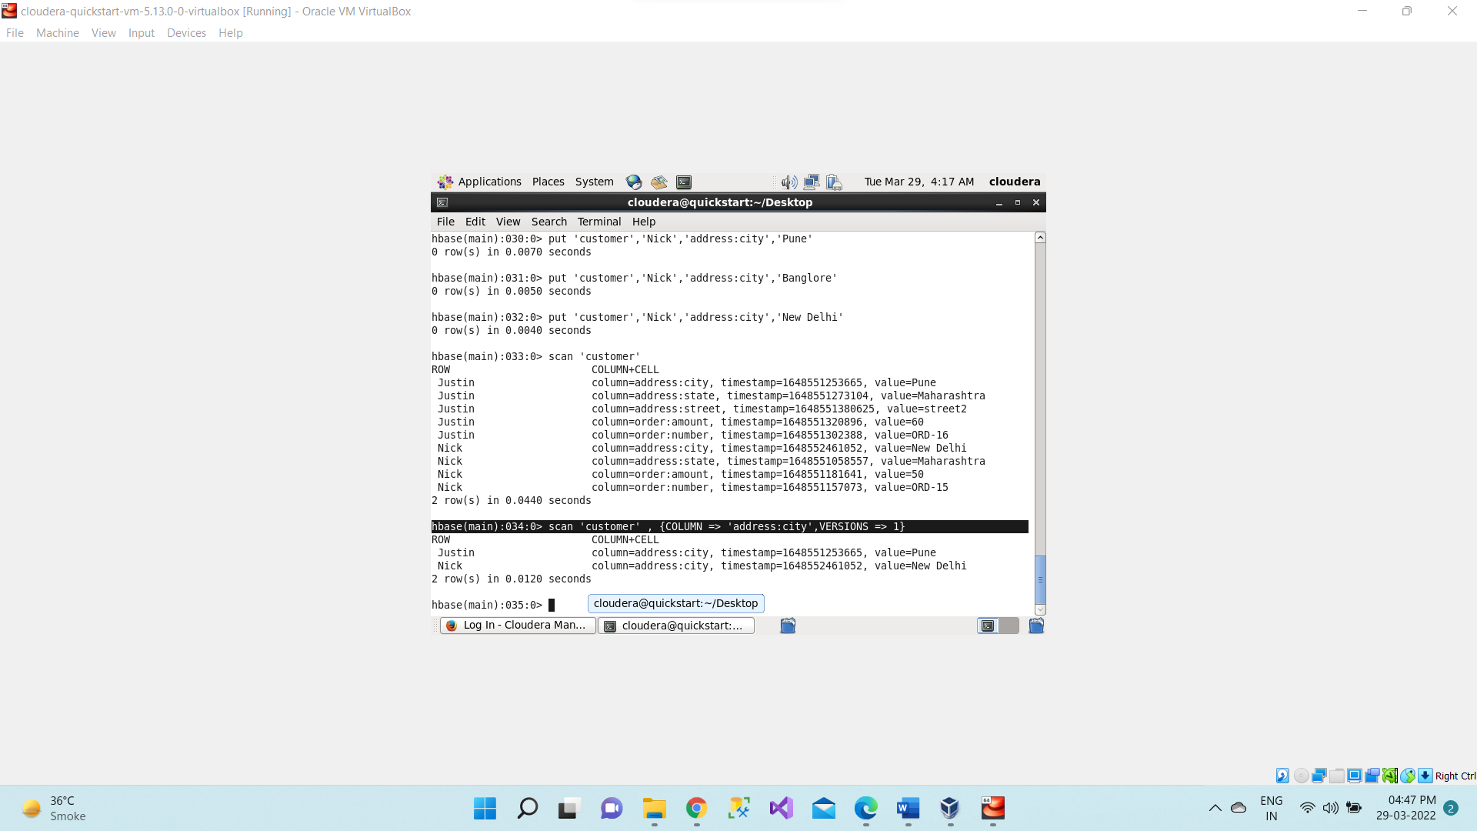

**>scan 'customer', {COLUMN=> 'address:city', VERSIONS => 0}**

**>scan 'customer', {COLUMN=> 'address:city', VERSIONS => 4}**

**>scan 'customer', {COLUMN=> 'address:city', VERSIONS => 5}**

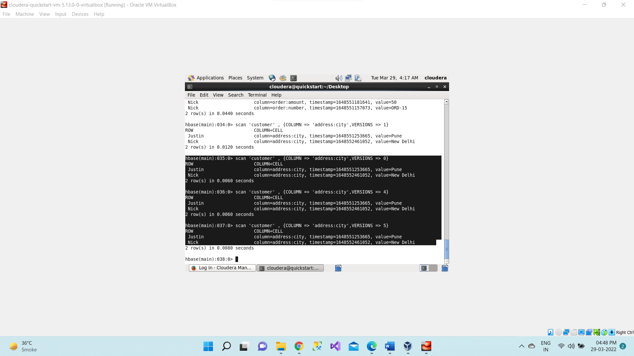

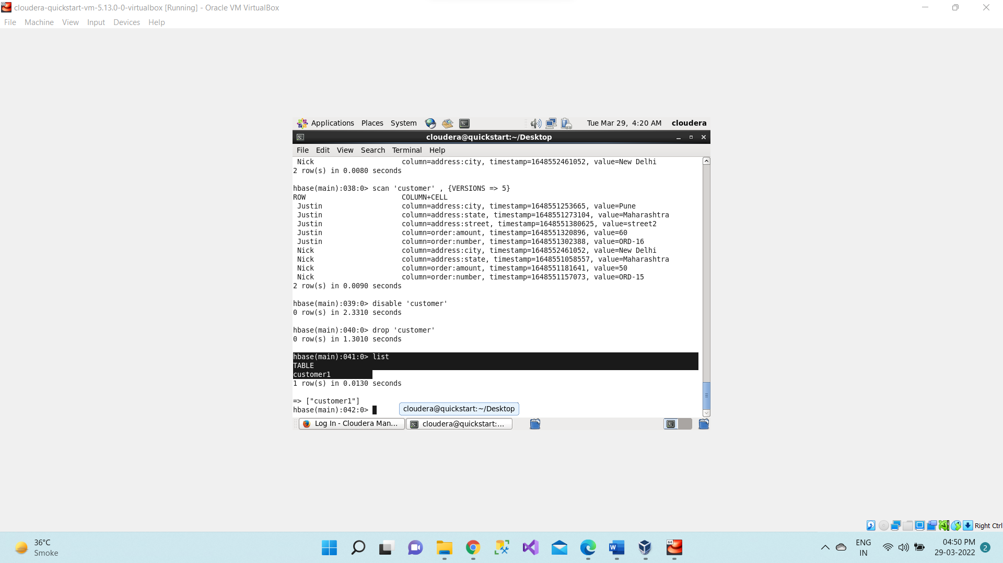

**>scan 'customer', {VERSIONS => 5 } – This for all columns not for any specific column**

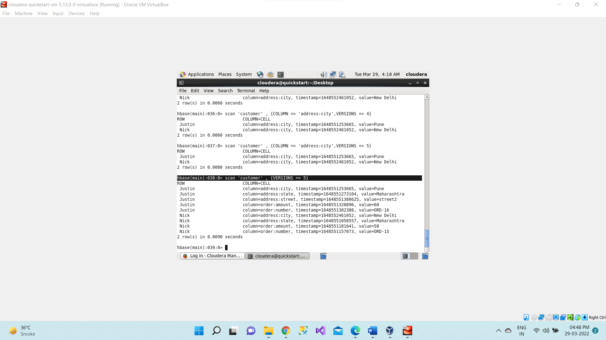

1. **Disable -This command will start disabling the named table**

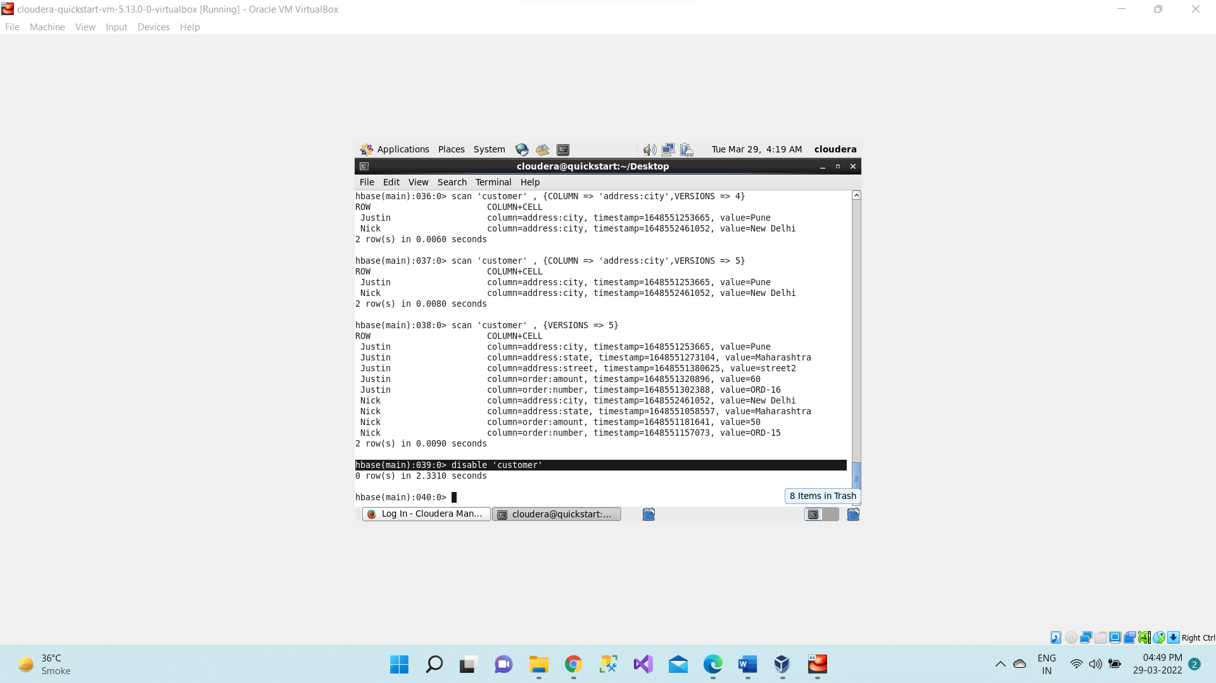

1. Drop– It drops a table from HBase. Drop means complete deletion of table. For this first disable the table then drop it.

**drop 'customer'**

